**Traveling Salesman Problem: Genetic Algorithm**

Jacob Taylor Cassady

Computer Engineering & Computer Science

Speed School of Engineering

University of Louisville, USA

[jtcass01@louisville.edu](mailto:NameID@louisville.edu)

# Introduction

The Traveling Salesman Problem (TSP) is a well-known non-deterministic polynomial-time hard problem that has been studied within mathematics since the 1930s. The "salesman” is given a list of cities with their locations and is asked the shortest route to travel to each city once and then return to the starting point. A program was developed using Python 3.7 and accompanying 3rd party libraries: NumPy, Pandas, and matplotlib to determine the shortest path.

# Approach

The approach taken to solving the TSP was to use a genetic algorithm. Development of the algorithm was aided by a graphical user interface (GUI). Throughout this document cities from TSP will be referred to as “vertices” and the route between a pair of vertices as an “edge.”

## Algorithm

The genetic algorithm implemented is inspired by sexual reproduction of gametes in biology. This algorithm retains a constant population of “chromosomes” which are representations of possible solutions/agents for/within the given problem. The algorithm then makes use of two functions to evolve the population overtime to weed out the poor performers and mate the good performers. The mating process is called “crossover”. An additional method is used after cross over to add more randomization into the process, this method is called “mutation”.

### Crossover

d

### Mutation

d

## Graphical User Interface

To aid in the development of the algorithm, a GUI was developed to track the updates to the program’s state. The GUI has 5 command buttons and a graph display. The command buttons include: “Step Forward”, “Step Backward”, “Run Simulation”, “Finish Simulation”, and “Show All Edges” or ”Show Current Route”. For reference to the GUI during different states of the algorithm’s execution, please refer to **Figures 11-17** in the Appendix of this paper.

### Step Forward

The step forward button calls step_forward on the algorithm. In the case of the greedy closest edge algorithm, it finds the nearest vertex to the route and lassos it.

### Step Backward

The step backward button calls step_backward on the algorithm. It reverses the previous step forward operation.

### Run Simulation

The run simulation button iterates through the algorithm’s step_forward function until the algorithm raises a True done flag. It shows each step in the simulation as it occurs.

### Finish Simulation

The finish simulation button iterates through the algorithm’s step_forward function until the algorithm raises a True done flag. It does not show each step in the simulation as it occurs, only the final product.

### Show All Edges / Show Current Route

This button toggles between showing the graph with all edges connected to showing only the vertices and the route traveled. The text on the button toggles to match its use case.

# Results

The Greedy algorithm with a Closest Edge Insertion Heuristic was successfully implemented. The algorithm produces a route that visits each city while minimizing the route distance. The algorithm did not have any issues running with only 4 GB of RAM on datasets with up to 40 cities. No mitigation techniques were needed to reduce program memory usage or improve runtime efficiency.

## Data

The algorithm was tested using four different datasets each generated with a number of randomly located cities. The files tested had 11, 12, 30, and 40 cities. Within the datafile, cities are enumerated, and x and y coordinates are provided. The input data was formatted like the example shown in **Figure 2** below.

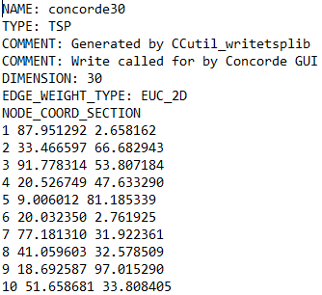

Figure 2 : 30Random.tsp Input Data

## Results

The results from processing the different files using the previously described algorithm can be found in **Table 1** shown below.

|  |  |  |  |  |
| --- | --- | --- | --- | --- |
| Filename | Distance traveled | Algorithm Runtime | Route Order | Insert order |
| Random30.tsp | 509.213 | 0.11372s | 8, 10, 15, 30, 1, 24, 7, 17, 21, 3, 19, 28, 23, 16, 11, 12, 2, 14, 22, 27, 9, 5, 26, 18, 4, 29, 13, 25, 6, 20, 8 | 8, 10, 16, 11, 12, 18, 4, 29, 13, 25, 6, 20, 2, 14, 26, 5, 9, 27, 22, 17, 7, 30, 24, 15, 1, 23, 19, 3, 21, 28, 8 |
| Random40.tsp | 625.171 | 0.27526s | 1, 24, 30, 7, 17, 40, 10, 16, 23, 21, 3, 19, 32, 28, 34, 36, 37, 11, 12, 18, 2, 14, 22, 27, 9, 5, 26, 35, 4, 33, 31, 13, 25, 6, 20, 29, 38, 8, 39, 15, 1 | 1, 24, 30, 15, 7, 17, 40, 10, 16, 11, 12, 18, 8, 39, 35, 4, 33, 38, 29, 31, 13, 25, 6, 20, 37, 26, 14, 2, 23, 34, 19, 36, 28, 32… |
| Random11.tsp | 252.684 | 0.007s | 1, 6, 10, 11, 8, 9, 7, 5, 3, 4, 2, 1 | … |
| Random12.tsp | 66.085 | 0.00797s | 1, 8, 2, 3, 12, 4, 9, 5, 10, 6, 7, 11, 1 | … |

Table 1 : Algorithm Performance Per Test File

The table above shows the algorithm successfully completed even 40 cities in a little over half a second. Although this is over twice as long as it took to complete 30 cities, it is still relatively quick given the number of possibilities a brute force algorithm would have to sift through for the same dataset.

Figure 3 : Algorithm Runtime v. Number of Cities Within File

# Discussion

A graph of the number of cities within a file versus the algorithm runtime was presented in **Figure 3** above. As you can see it still looks like it is exponentially shaped but with a less steep curve than brute force. This shows the greedy algorithm using the closest edge insertion heuristic can handle growing datasets much better than the brute force approach while still providing an answer that lacks crossing edges.

Several equations exist for computing the distance between a line, given two points, and a third point outside of the line. A problem found when implementing this algorithm is that many of those equations assume the line extends infinitely past the segment bound by the two points including the equation described [here](http://mathworld.wolfram.com/Point-LineDistance2-Dimensional.html). This made understanding the behavior of the program and calculations within challenging at first.

# References

Wikipedia, Traveling Salesman Problem - <https://en.wikipedia.org/wiki/Travelling_salesman_problem#History>

NumPy Documentation - <https://docs.scipy.org/doc/>

Pandas Documentation - <https://pandas.pydata.org/pandas-docs/stable/>

Matplotlib Documentation - <https://matplotlib.org/3.1.1/contents.html>

# Appendix

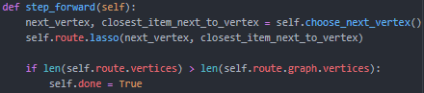

Figure 4: TravelingSalesman.GreedyAlgorithm.step_forward()

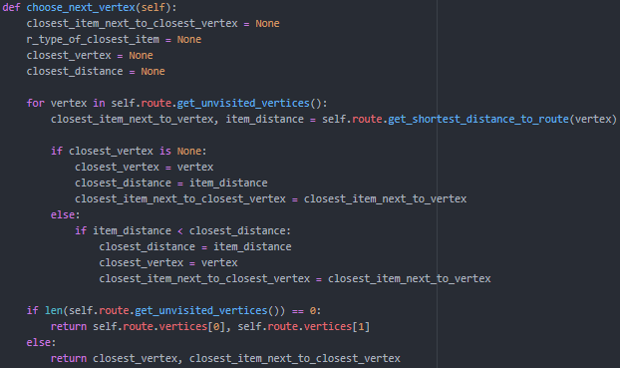

Figure 5: TravelingSalesmane.GreedyAlgorithm.choose_next_vertex()

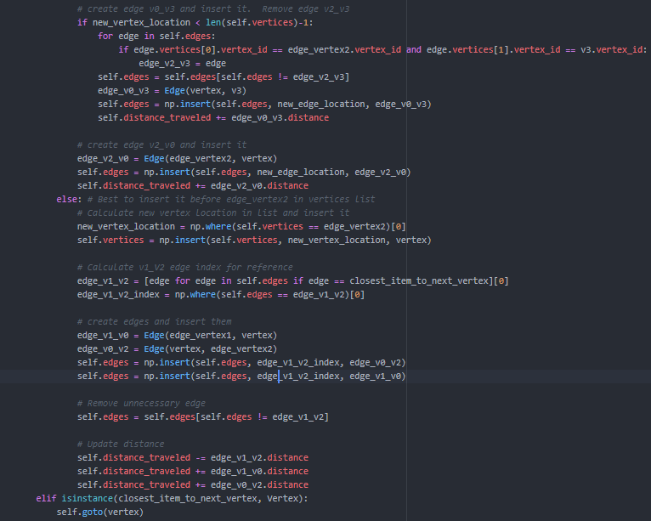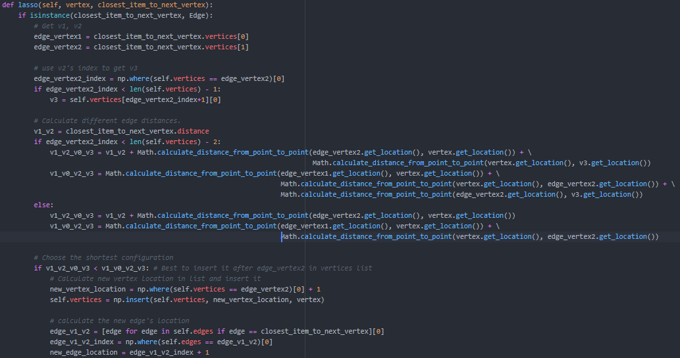

Figure 6 : Route.lasso(vertex, closest_item_to_vertex)

Figure 7 : Random30.tsp Input

Figure 8 : Random40.tsp Input

Figure 9 : Random30.tsp Output

Figure 10 : Random40.tsp Output

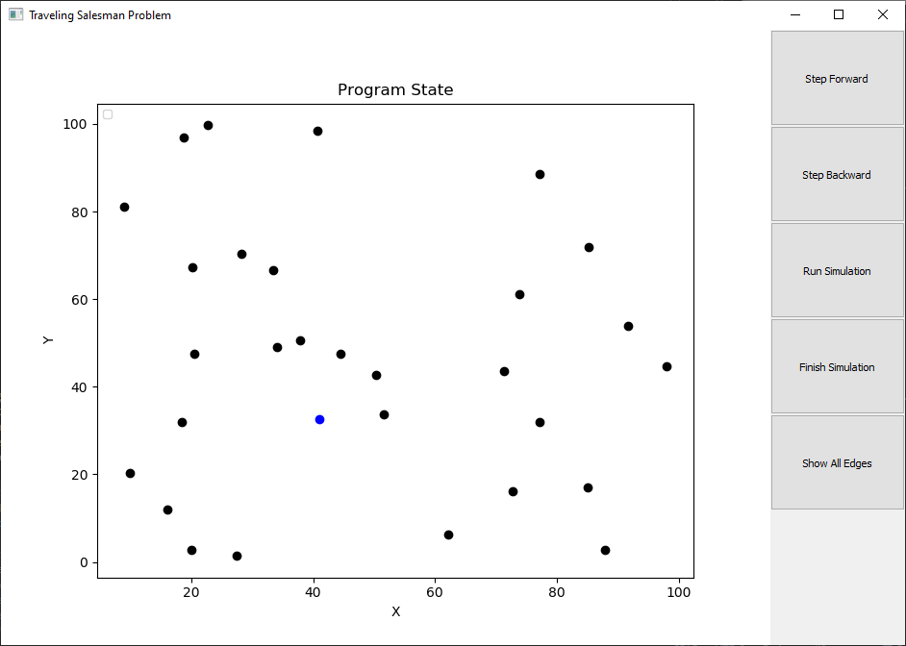

Figure 11 : Program State 0 [Random30.tsp]

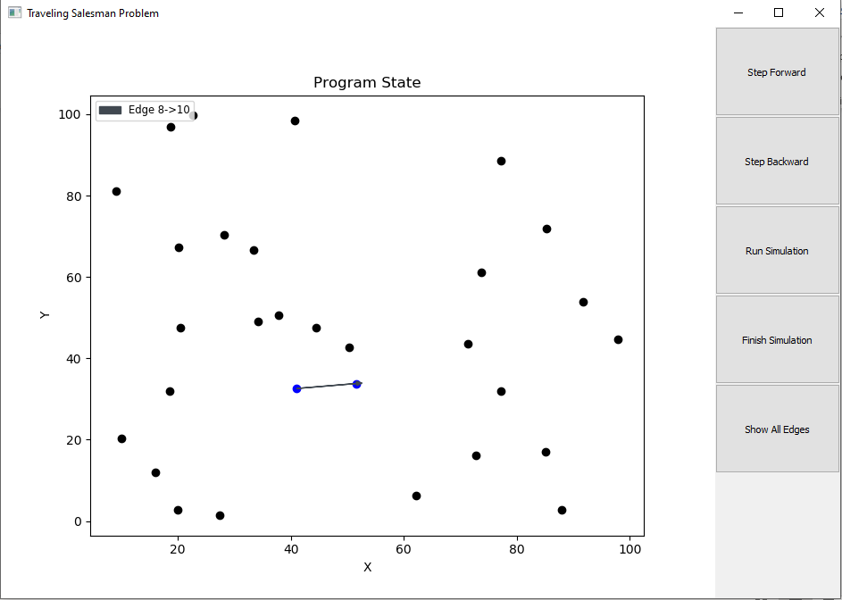

Figure 12 : Program State 1 [Random30.tsp]

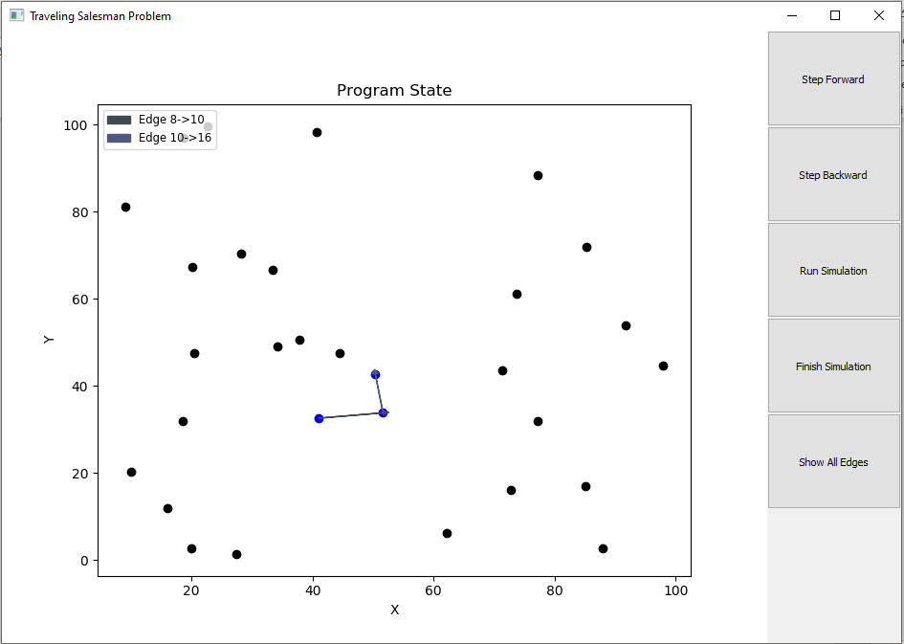

Figure 13 : Program State 3 [Random30.tsp]

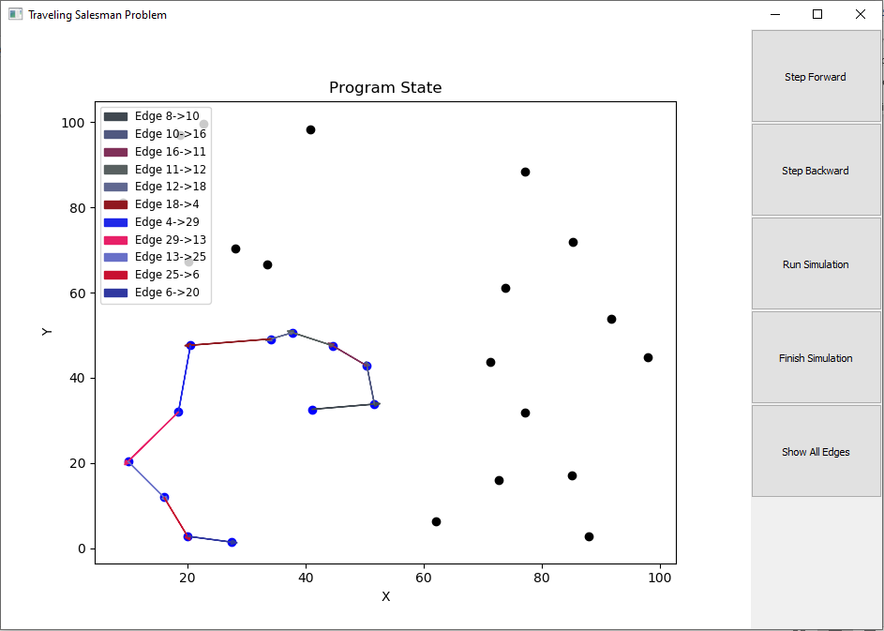

Figure 14 : Program State 11 [Random30.tsp]

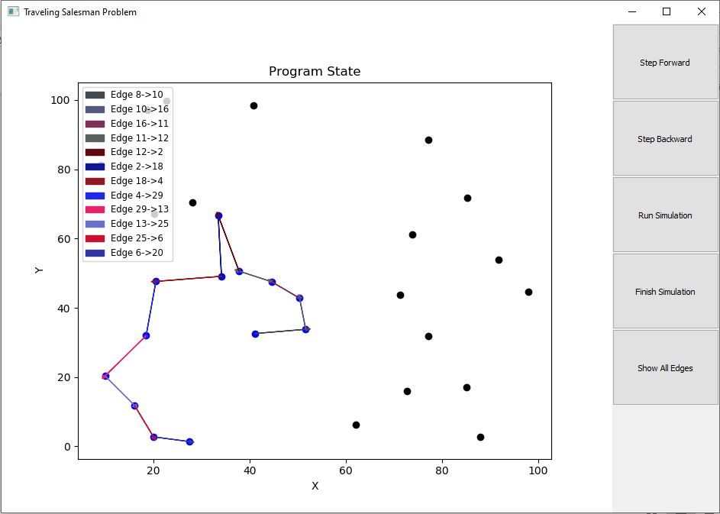

Figure 15 : Program State 12 [Random30.tsp]

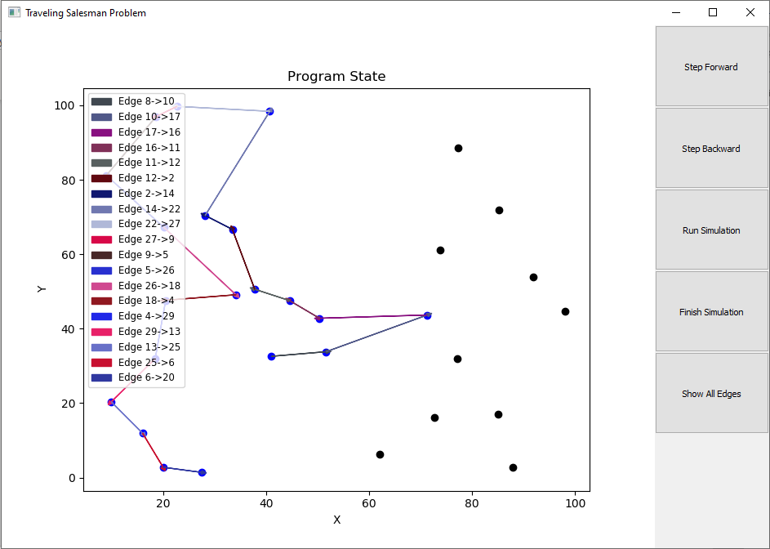

Figure 16 : Program State 19 [Random30.tsp]

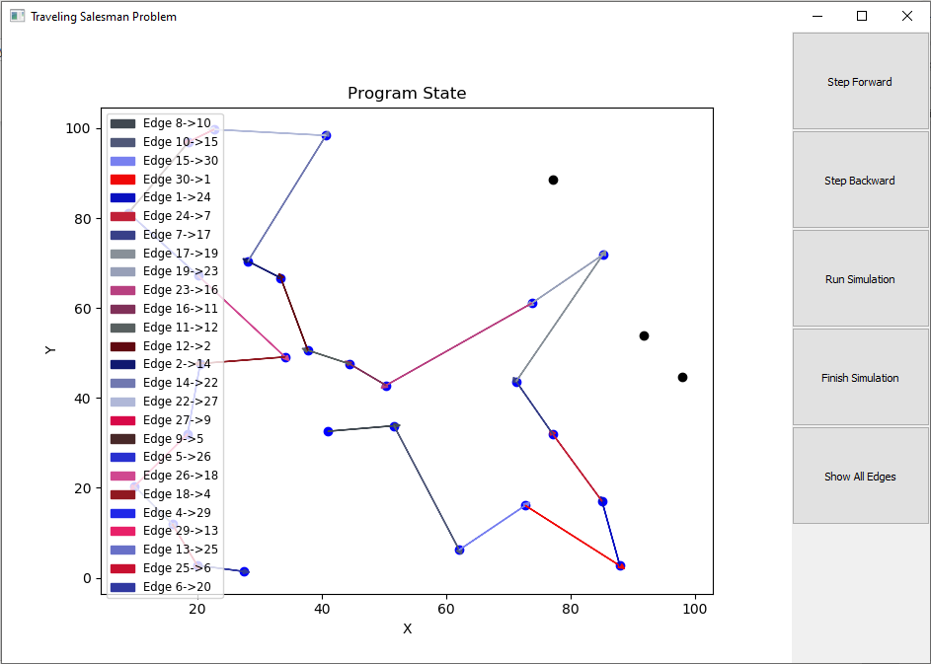

Figure 17 : Program State 26 [Random30.tsp]